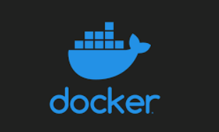

DOCKER with REACT

=> there are three major benefits of the using docker like :-
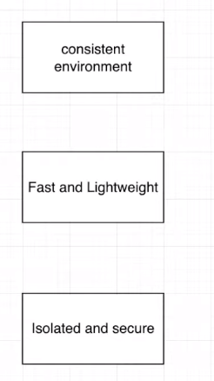

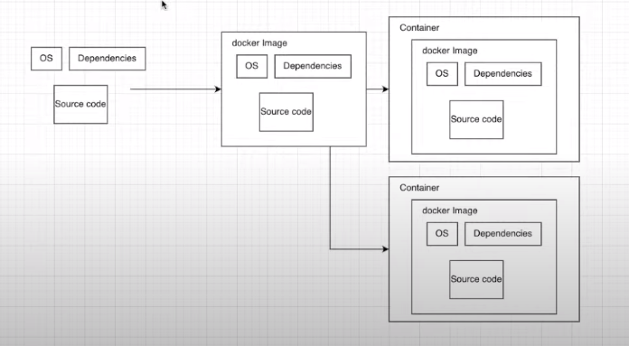

-- creating react app inside the react-docker folder.

-- then we will make image and will run in a container.

-- actually docker makes a mini computer itself which have it’s own os , cpu cores, and network (subnetting in docker) actually these things are logically and it get and make all these using the host machine .
And in that mini computer we run our application .

--docker containers run on linux kernels so now you will think

win/mac --> docker_desktop—hyperkit(hyperviser)--
lin --> docker_desktop

(hyperviser is responsible for virtualization between the os and the virtual machines/containers we are creating)
linux don’t need hyperviser because linux machine is already have linux kernel .

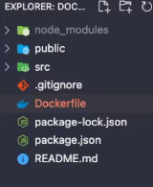
-- that’s why docker runs slow on win and mac compared to linux machine so if you want to user docker with it’s full power then you need linux machine .

-- --------------------------------------------------------------------------------------
--> in root folder make a Dockerfile
> in this we need to write something
<1> FROM
-- in docker there is a concept of base image , the image
going to be created it requires certain things like : OS(which operating system we are going to use( normally os level dependencies we take from the base image)
-- it is like we are using inheritance


-- so the image name is node and tag 16 shows the version
-- so this is the base image and it is uloaded on dockerhub
-- this base image contains all the things like linux os that we
need
-- on top of this we add layers of the application
-- this image is created in layers .
<2> WORKDIR/app
-- when our container runs it have it’s own file system in which we
need to tell the working directory / Home directory of our app.
** till now app will not be there but this will create the app
folder in the working directory .

<3> COPY ./package*.json ./

* selects both package.json an package.lock.json (wildcard)
and copy in docker

<4> RUN npm install
-- all the dependencies will be installed inside the package.json

<5> COPY . .
-- . means current working directory
-- so copy all the contents of the current working directory inside
the (second dot)

<6> CMD [“npm”. “run”, “start”]

NOTE : commands(1-5) will run during the build but
cmd run command will run when our containers get started

-----------------------------------------------------------------
=> in term
1> make sure you have docker
2> command to build image

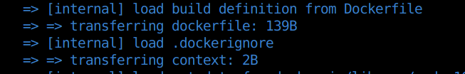

-----------------------------------------------------------
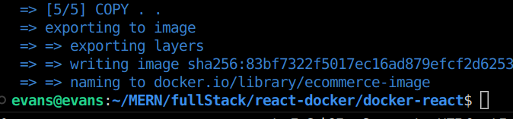

-> -t stands for the tag(you can give any tag/name) for the image
-> . tells the location of the Dockerfile so you need to mention
location since it is in the root dir so we just mentioned .

-- building process starts
-- first base image is downloaded and then local code and dependen-
dencies get downloaded
-- image will get ready

--> first time it takes time and lots of data but from next time
it get cached locally and and it get completed immediately .
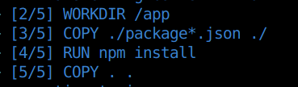
--You can see that five tasks were
there and how it is getting
completed one by one .

-- next time it uses the cached version .

* in linux we don’t need docker desktop and we can just go with the
docker engine .
* basically this is for development environment and here we are not
ignoring the node modules but for the production/deployment we do
ignore the node modules to keep the image light weight .

---------------

=> there is a concept of the bind_mount and volumes in the docker
-- whenever we use node_modules we need to use that as anonymous
volume .
-- here in dev environment we are not ignoring the nodemodules
but you can in .dockerignore if you want.
---------------

=> our image have been created and we can see it using
-- docker image ls
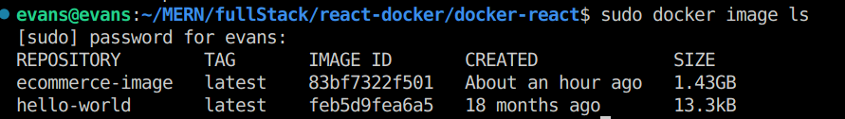
-- we need to use sudo or use as superuser

-- here you can see the image details (nname : ecommerce-image)
-- it is very big because node modules are also inside this
-- but if you want to ignore using dockerignore then you can

=> with the image we are going to run the container so we’ll do this
-- Note: you need to use sudo to avoid the error of auth
-- if you will not give name to the container then it will give
automatically
-- --rm to remove the existing running container to avoid the
name conflict
-- then put image name
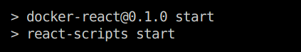
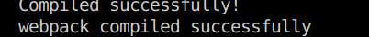

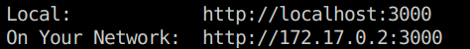



-- but our application didn’t get start because
-- we know container has it’s own network and this localhost is of
the container on which no app is running
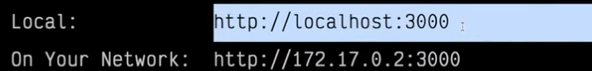

** this localhost is not the localhost of the host machine.

=>to solve this we can do
-- first close the container
-- you can see all the log the current containers
=> to stop the running containers we can use the command :-
-- you can use the iD or name of the container also .

--> so to run the container we need to map the ports of the
container with the host machine
-> where you can give any name of the container
-> --rm to avoid the conflict
-> -p 3000:3000 first port if of container and the second one is of
the host machine and we are mapping
-> -d is to run in the detatched format and keep the terminal clear

-> you can see the container id in the terminal .
-> to see the running containers you can use docker ps

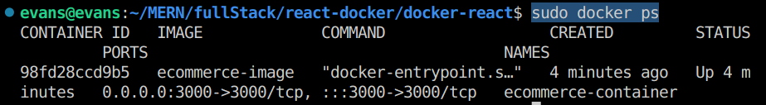

-> you can see this in the ui of the docker desktop also .

-> and now it is running on the localhost of the host
machine

=> BIND_MOUNT :-
-> suppose you want to change the code and you put
<h1> React with the Docker </h1>

-> then no change will be reflect in the localhost of the host machine because this running code is of the container and you are changing the code in the host machine .

-> so you need to sync the pwd of the host machine and /app (direcory of the app in the containers directory)
-------------------------------------------------------------------
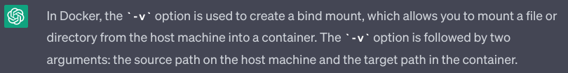
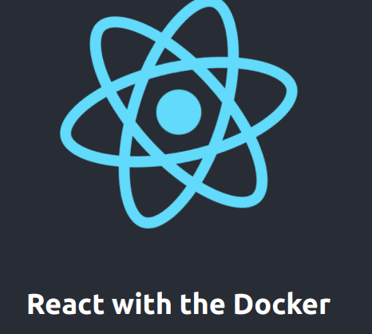

-> or we can also use v flag for the verbose output .
----------------------------------------------------
-> now you can see the changes reflecting

--> you can also check the logs
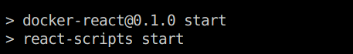
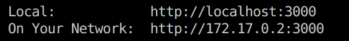

-> it is running fine .

=> instead of the -d (detatched mode ) you can use -it (interactive)

****** docker runs very fast in linux ******
because it direct interact with the kernel .

-> to check the sync you can put one more line of the code

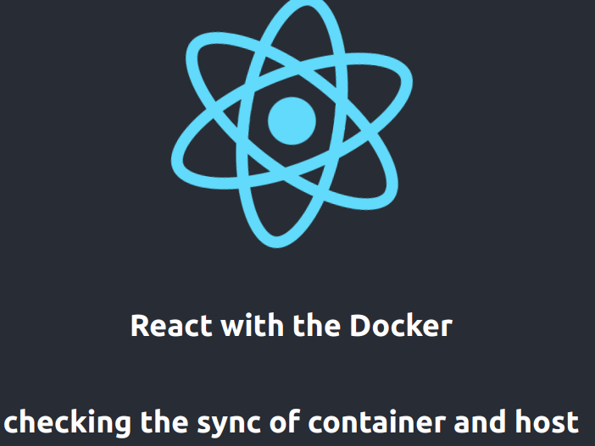

-> you can see that it is perfectly
synced .
-> hot reload

=> in devops we also use EXPOSE :-
-> to tell the ports .
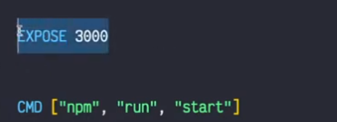
-> it is just for the documentation purpose .

-> so it becomes easy to know which port we
need to expose .

> HW <
make next.js application in the docker .

